Westminster Presbyterian Church
A Service for the Worship of God
Thirteenth Sunday after Pentecost
September 4, 2022

We Gather in God’s Word

Chiming the Hour

Prelude

Words of Scripture Psalm 23

The Lord is my shepherd, I shall not want.
He makes me lie down in green pastures.
He leads me beside still waters. He restores my soul.
He leads me in right paths for his name’s sake.
Welcome and Announcements Len Bornemann

*Call to Worship Psalm 5

In the morning you hear our voices.
Through the abundance of your steadfast love
We enter your house.
We bow down toward your holy temple in awe of you.
Lead us, O Lord, in your righteousness
Because of our enemies.
Make your way straight before us.
Let all who take refuge in the Lord rejoice.
Let them ever sing for joy.

*Hymn #139 “Come, Thou Almighty King” Italian Hymn

Come, Thou Almighty King, Help us Thy name to sing,
Help us to praise: Father, all-glorious, O’er all victorious,
Come, and reign over us, Ancient of Days.

Come, Thou Incarnate Word, Gird on Thy mighty sword,
Our prayer attend: Come, and Thy people bless, And give Thy word success;
Spirit of holiness, On us descend.

Come, Holy Comforter, Thy sacred witness bear
In this glad hour: Thou who almighty art, Now rule in every heart,
And ne’er from us depart, Spirit of power.

To Thee, great One in Three, The highest praises be,
Hence evermore! Thy sovereign majesty May we in glory see,
And to eternity Love and adore.

Call to Confession

Prayer of Confession

Gracious God, our sins are too heavy to carry, too real to hide, and too deep to undo. Forgive what our lips tremble to name, what our hearts can no longer bear, and what has become for us a consuming fire of judgment.

We pause for a time of personal prayer.

Set us free from a past that we cannot change; open to us a future in which we can be changed; and grant us grace to grow more and more in your likeness and image; through Jesus Christ, the light of the world. Amen.

Assurance of Pardon

*Gloria Patri

Glory be to the Father, and to the Son, and to the Holy Ghost.
As it was in the beginning, is now, and ever shall be, world without end. Amen, Amen.

*Passing the Peace

The peace of Christ be with you. And also with you.

We Hear God’s Word

Time for All God’s Children

Prayer of Illumination

First Scripture Lesson Luke 14:25-33(850) (908)

25 Now large crowds were travelling with him; and he turned and said to them, ²⁶‘Whoever comes to me and does not hate father and mother, wife and children, brothers and sisters, yes, and even life itself, cannot be my disciple. ²⁷Whoever does not carry the cross and follow me cannot be my disciple. ²⁸For which of you, intending to build a tower, does not first sit down and estimate the cost, to see whether he has enough to complete it? ²⁹Otherwise, when he has laid a foundation and is not able to finish, all who see it will begin to ridicule him, ³⁰saying, “This fellow began to build and was not able to finish.” ³¹Or what king, going out to wage war against another king, will not sit down first and consider whether he is able with ten thousand to oppose the one who comes against him with twenty thousand? ³²If he cannot, then, while the other is still far away, he sends a delegation and asks for the terms of peace. ³³So therefore, none of you can become my disciple if you do not give up all your possessions.

Second Scripture Lesson Jeremiah 18:1-11 (629) (666)

The word that came to Jeremiah from the Lord: “Come, go down to the potter’s house, and there I will let you hear my words.” So I went down to the potter’s house, and there he was working at his wheel. The vessel he was making of clay was spoiled in the potter’s hand, and he reworked it into another vessel, as seemed good to him. Then the word of the Lord came to me: Can I not do with you, O house of Israel, just as this potter has done? says the Lord. Just like the clay in the potter’s hand, so are you in my hand, O house of Israel. At one moment I may declare concerning a nation or a kingdom, that I will pluck up and break down and destroy it, but if that nation, concerning which I have spoken, turns from its evil, I will change my mind about the disaster that I intended to bring on it. And at another moment I may declare concerning a nation or a kingdom that I will build and plant it, but if it does evil in my sight, not listening to my voice, then I will change my mind about the good that I had intended to do to it.

Now, therefore, say to the people of Judah and the inhabitants of Jerusalem: Thus says the Lord: Look, I am a potter shaping evil against you and devising a plan against you. Turn now, all of you from your evil way, and amend your ways and your doings.

This is the Word of the LORD. Thanks be to God.

Sermon “Follow My Lead” Rev. Caroline V. Dennis
Whoever does not carry the cross and follow me cannot be my disciple.
Luke 14:27

We Respond to God’s Word

* Hymn #339 “Be Thou My Vision” Slane

Be Thou my vision, O Lord of my heart; Naught be all else to me, save that Thou art--
Thou my best thought, by day or by night, Waking or sleeping, Thy presence my light.

Riches I heed not, nor man’s empty praise, Thou mine inheritance, now and always:
Thou and Thou only, first in my heart, Great God of heaven, my treasure Thou art.

Be Thou my wisdom, and Thou my true word; I ever with Thee and Thou with me, Lord;
Heart of my own heart, whatever befall, Still be my vision, O Ruler of all.

Prayers of the People and the Lord’s Prayer

Our Father who art in heaven, hallowed be thy name. Thy kingdom come, thy will be done, on earth as it is in heaven. Give us this day our daily bread, and forgive us our debts as we forgive our debtors; and lead us not into temptation, but deliver us from evil. For thine is the kingdom and the power and the glory, forever. Amen.

Call to Offering

*Offertory Hymn #513 “Let Us Break Bread Together” Let Us Break Bread

Let us break bread together on our knees; (on our knees;)
Let us break bread together on our knees. (on our knees.)
When I fall on my knees, With my face to the rising sun,
O Lord, have mercy on me. (on me.)

Let us drink wine together on our knees; (on our knees;)
Let us drink wine together on our knees. (on our knees.)
When I fall on my knees, With my face to the rising sun,
O Lord, have mercy on me. (on me.)

Let us praise God together on our knees; (on our knees;)
Let us praise God together on our knees. (on our knees.)
When I fall on my knees, With my face to the rising sun,
O Lord, have mercy on me. (on me.)

The Sacrament of Holy Communion
Invitation
Prayer of Great Thanksgiving
The Lord be with you.
And also with you.

Lift up your hearts.
We lift them to the Lord.

Let us give our thanks to the Lord our God.
It is right to give our thanks and praise.

Communion of the People

Prayer after Communion

*Hymn #388 “O Jesus, I Have Promised” Angel’s Story

O Jesus, I have promised To serve Thee to the end;
Be Thou forever near me, My Master and my Friend;
I shall not fear the battle If Thou art by my side,
Nor wander from the pathway If Thou wilt be my guide.

O let me feel Thee near me! The world is ever near;
I see the sights that dazzle, The tempting sounds I hear;
My foes are ever near me, Around me and within;
But Jesus, draw Thou nearer, And shield my soul from sin.

O let me hear Thee speaking In accents clear and still,
Above the storms of passion, The murmurs of self will;
O speak to reassure me, To hasten or control;
O speak, and make me listen, Thou guardian of my soul.

O Jesus, Thou hast promised To all who follow Thee
That where Thou art in glory There shall Thy servant be;
And, Jesus, I have promised To serve Thee to the end;
O give me grace to follow, My Master and my friend.

Charge and Benediction

Postlude
[*All stand as they are able.]

Serving Today at Westminster
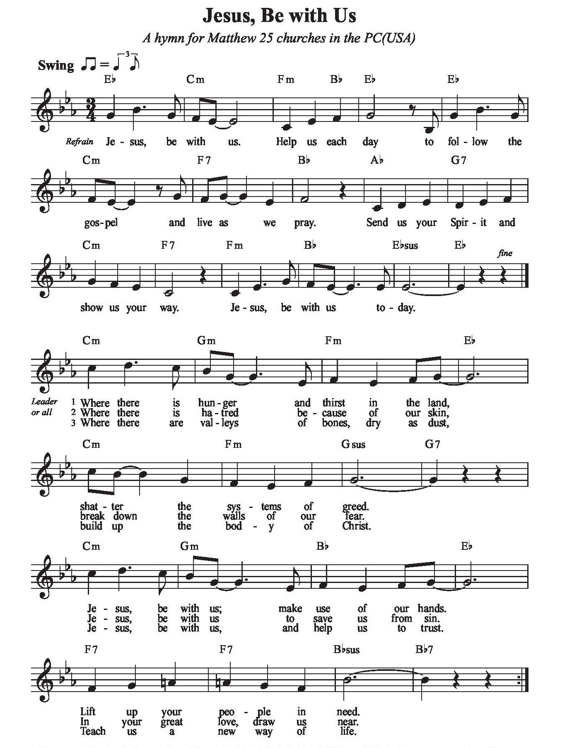
Organist: Claire Kuhl
Vocalists: Laura Margaret Fennell
Liturgists: Len Bornemann
Worship Hosts: Beth and David Hammond
Tech Team: Phillip and Jacob Dennis
Adult Sunday School: Caroline Dennis
Children’s Sunday School Kathy Gillespie and Rob Graves
Next Sunday, September 11
9:00 Sunday School Youth Room
10:00 Worship Sanctuary
11:00 Congregational Meeting (immediately after the worship service)

ANNOUNCEMENTS

Sunday School

Today is week 5 of the 6 week program on The Lord’s Prayer being led by Rev. Caroline Dennis. In this insightful 6-week study, author Adam Hamilton helps you find a deeper understanding of the petition you may have come to recite without thinking. Learn how it can serve as a pattern for your everyday devotional life.

Beginning September 18, 2022, we will be continuing with the Mighty Acts of God. Teachers will include Claire Kuhl, Bill Jacobs and Doug Kauffmann in a rotation. Watch for more information.

Congregational Meeting

There will be a Congregational Meeting on September 11, 2022, immediately following the worship service. At the meeting the report of the Nominating Committee will be received and that the following slate of officers will be presented:

Elder Class of 2023 Richard Wilson
Elders Class of 2025 Rob Graves
Tina Corley

Nominating Committee Class of 2023
Claire Kuhl, chairperson
David Bell
Elizabeth Watkins
PW Bible Study

Monday, September 12 is the kick-off for Women’s Dessert and Bible Study. Join the fun at 6:30 in the Fellowship Hall.

Labor Day

The office will be closed to celebrate Labor Day. Should you have an emergency, please contact our pastor, Caroline Dennis at 317.777.1487.

WESTMINSTER PRESBYTERIAN CHURCH
An Inclusive Community of Faith
United by Our Belief in and Commitment to Jesus Christ
Office Hours: M-Th 9:00 a.m. – Noon Office Phone: 864. 229.3595
www.wpcgnwd.org wpcgwd1@gmail.com

Reverend Caroline Vinson Dennis
Pastor (317.777.1487)
Sunday Study 9:00 a.m. Church Service: 10:00 a.m.
CCLI License #2724601 and #20189191

