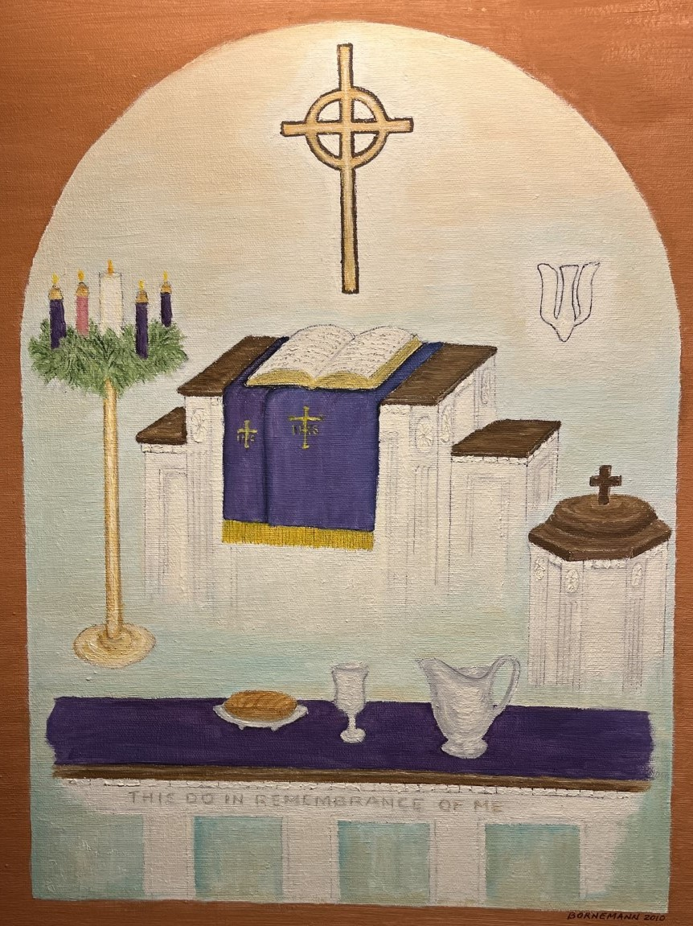
Westminster Presbyterian Church
First Sunday in Advent

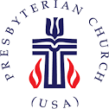
A Service for the Worship of God
The First Sunday of Advent
November 27, 2022

We Gather in God’s Word
Chiming of the Hour
Prelude
Words of Scripture Nancy Hart Wicker

I was glad when they said to me, Psalm 122:1
Let us go to the house of the Lord!
Welcome and Announcements
Advent Candle Lighting Isaiah 2:2-4

O house of Jacob, let us walk in the light of hope.
Let us walk in the light of the Lord.

*Hymn #8 “Lift Up Your Heads, Ye Mighty Gates” Truro

Lift up your heads, ye mighty gates, Behold, the King of glory waits;
The King of kings is drawing near; The Savior of the world is here!

Fling wide the portals of your heart; Make it a temple, set apart
From earthly use for heaven's employ, Adorned with prayer and love and joy.

Redeemer, come! I open wide My heart to Thee: here, Lord, abide.
Let me Thy inner presence feel; Thy grace and love in me reveal.

Call to Confession

Prayer of Confession

God of night and day, there is no shadow that can conceal our sin from you and no secret that you will not bring to light. We know that we have fallen short and over stepped. Forgive our inattention to your daily advent, our offenses against our neighbors, and our excesses.

We pause for a time of personal prayer.

O God, renew us in love and teach us to live in a way that brings honor and glory to your name; through Jesus Christ our Lord. Amen.
Assurance of Pardon

Beloved, in your baptism, you were bathed in light and clothed with grace. Therefore, put on the Lord Jesus Christ! Know that you are forgiven and live in peace.

*Response of Praise Winchester New
Hymn #10 v.4
All praise to You, eternal Son,
Whose advent has our freedom won,
Whom with the Father we adore and Holy Spirit evermore.

*Passing the Peace

The peace of Christ be with you. And also with you.

We Hear God’s Word

Time for All God’s Children Bill Jacobs

Prayer of Illumination

First Scripture Reading Romans 13:11-14

¹¹Besides this, you know what time it is, how it is now the moment for you to wake from sleep. For salvation is nearer to us now than when we became believers; ¹²the night is far gone, the day is near. Let us then lay aside the works of darkness and put on the armor of light; ¹³let us live honorably as in the day, not in reveling and drunkenness, not in debauchery and licentiousness, not in quarreling and jealousy. ¹⁴Instead, put on the Lord Jesus Christ, and make no provision for the flesh, to gratify its desires.

Second Scripture Reading Matthew 24:36-44

³⁶“But about that day and hour no one knows, neither the angels of heaven, nor the Son, but only the Father. ³⁷For as the days of Noah were, so will be the coming of the Son of Man. ³⁸For as in those days before the flood they were eating and drinking, marrying and giving in marriage, until the day Noah entered the ark, ³⁹and they knew nothing until the flood came and swept them all away, so too will be the coming of the Son of Man. ⁴⁰Then two will be in the field; one will be taken and one will be left. ⁴¹Two women will be grinding meal together; one will be taken and one will be left. ⁴²Keep awake therefore, for you do not know on what day your Lord is coming. ⁴³But understand this: if the owner of the house had known in what part of the night the thief was coming, he would have stayed awake and would not have let his house be broken into. ⁴⁴Therefore you also must be ready, for the Son of Man is coming at an unexpected hour.

This is the Word of the LORD.
Thanks be to God.

Sermon “Attentive” Rev. Caroline V. Dennis

“Therefore, you also must be ready,
for the Son of Man is coming at an unexpected hour."
Matthew 24:44

We Respond to God’s Word
Call to Prayer
Hymn #9 “O Come, O Come, Emmanuel” Veni Emmanuel

O come, O come, Emmanuel, And ransom captive Israel,
That mourns in lonely exile here Until the Son of God appear.

[Refrain]
Rejoice! Rejoice!
Emmanuel shall come to thee, O Israel.

O come, Thou Day-spring, come and cheer Our spirits by Thine advent here;
Disperse the gloomy clouds of night, And death's dark shadows put to flight. [Refrain]

O come, Desire of nations, bind All peoples in one heart and mind;
Bid envy, strife, and discord cease; Fill the whole world with heaven's peace. [Refrain
Prayers of the People and the Lord’s Prayer

Our Father who art in heaven, hallowed be thy name. Thy kingdom come, thy will be done, on earth as it is in heaven. Give us this day our daily bread, and forgive us our debts as we forgive our debtors; and lead us not into temptation, but deliver us from evil. For thine is the kingdom and the power and the glory, forever. Amen.

Call to Offering

Offertory “Love the Ones You’re With” John Campbell Lake

*Doxology

Praise God, from Whom all blessings flow, Praise Him, all creatures here below;
Praise Him above, ye heavenly host; Praise Father, Son, and Holy Ghost. Amen.
*Affirmation of Faith Apostles Creed

I believe in God the Father Almighty, maker of heaven and earth;

And in Jesus Christ his only Son our Lord: who was conceived by the Holy Ghost, born of the Virgin Mary, suffered under Pontius Pilate, was crucified, dead, and buried; he descended into hell; the third day he rose again from the dead; he ascended into heaven, and sitteth on the right hand of God the Father Almighty; from thence he shall come to judge the quick and the dead.

I believe in the Holy Ghost, the holy catholic church, the communion of saints, the forgiveness of sins, the resurrection of the body, and the life everlasting. Amen
*Hymn #2 “Come, Thou Long Expected Jesus” Hyfrydol

Come, Thou long expected Jesus, Born to set Thy people free;
From our fears and sins release us; Let us find our rest in Thee.
Israel's Strength and Consolation, Hope of all the earth Thou art;
Dear Desire of every nation, Joy of every longing heart.

Born Thy people to deliver, Born a child and yet a King,
Born to reign in us forever, Now Thy gracious kingdom bring.
By Thine own eternal Spirit Rule in all our hearts alone;
By Thine all sufficient merit Raise us to Thy glorious throne.
Thou Long-Expected Jesus” Hyfrydol

*Charge and Benediction
Postlude
[*All rise in body or in spirit.]

Serving Today at Westminster

Organist: Claire Kuhl
Vocalists: John Campbell Lake
Liturgist: Nancy Hart Wicker
Worship Hosts: The Wicker Family
Tech Team: Jacob Dennis and Rob Graves
Adult Sunday School: Arthur Gillespie

Today at Westminster
9:00 Sunday School: Faithful: Advent through the Eyes of Joseph
10:00 Worship

This Week at Westminster

Office Hours: 9:00 – 1:00 M-F

Prayer Concerns

Prayer concerns and joys may be shared using the prayer cards placed in the pew racks, our website contact page, or by email to the church office.
This week, please hold in prayer:

ANNOUNCEMENTS

John Campbell Lake brings us our special music today. We thank him for sharing his talents with us and enhancing our first Sunday of Advent worship.

New Advent Study Begins Today

Advent comes early this year, right on the heels of Thanksgiving. And you can be thankful for a unique new Sunday Study series. The study is called Faithful: Christmas Through the Eyes of Joseph, written by Adam Hamilton.
“
You are encouraged to order a copy of the student guide from your favorite online bookseller. The story of Joseph provides us a great example of humbly obeying God even when we don’t understand and faithfully moving forward in the strength that God provides.” For more information refer to the November edition of Westminster Times.
Poinsettia Orders

Poinsettias are available for purchase in honor or memory of a loved one, group or organization/ The Poinsettias will be placed in the church on the third Sunday of Advent, December11 and will be available for pickup after the Christmas Eve service. The cost is $20. Order forms are in the narthex.

The Poinsettias are grown and sold by Piedmont Technical College with the proceeds providing financial assistance for students in agriculture and horticulture.

Going Out Together

The Westminster church family is stepping out TOGETHER for: The University Singers Christmas Concert at Lander University, from4:00 – 6:00 om Sunday, December 4 in the Abney Cultural Center Auditorium. Our own Maggie Raborn is in the choir. The concert is free and open to the public. Foray Friends will meet in the lobby of the Auditorium at 3:45p.m.

Also, if you are going to attend the Lights at Connie Maxwell, December 1-3 (6:00 – 8:30), look for Elizabeth Watkins or Sally Kauffmann singing “Mary Did You Know” in the live nativity.

Advent Crafts

You are invited to come make Advent crafts during office hours from Monday thru Thursday. The crafts are set up in the Branches class room on the second floor immediately above the Parlor.
WESTMINSTER PRESBYTERIAN CHURCH
An Inclusive Community of Faith
United by Our Belief in and Commitment to Jesus Christ

Office Hours: M-Th 9:00 a.m. – Noon Office Phone: 864. 229.3595
www.wpcgnwd.org wpcgwd1@gmail.com

Clerk of Session |  | Treasurer |  | Office Manager
Steve Kuhl |  | Len Bornemann |  | Kathy Nave Felder
 |  | RULING ELDERS
Class of 2022 | Class of 2023 |  | Class of 2024 |  | Incoming 2025 Class
Kathy Gillespie | David Hammond |  | Kathy Nave Felder |  |  | Tina Corley
Emily Hughes | Richard Wilson |  | Claire Kuhl |  |  | Rob Graves
Reverend Caroline Vinson Dennis
Pastor (317.777.1487)
Sunday Study 9:00 a.m. Church Service: 10:00 a.m.
CCLI License #2724601 and #20189191

