Westminster Presbyterian Church
A Service for the Worship of God
Ninth Sunday after Pentecost
August 7, 2022

We Gather in God’s Word

Chiming the Hour

Prelude

Words of Scripture

Our help is in the Lord Psalm 124:8

Maker of heaven and earth.

Welcome and Announcements

*Call to Worship Psalm 145

Let each generation tell its children of your mighty acts.
Let them proclaim your power.

Everyone will share the story of your goodness
They will sing with joy about your righteousness

The eyes of all look to you with hope.
You give them food when they need it.

All your works will thank you, Lord.
All your faithful followers will praise you.

*Hymn #293 “This is My Father’s World” Terra Beata

This is my Father’s world, And to my listening ears
All nature sings, and round me rings The music of the spheres.
This is my Father’s world: I rest me in the thought
Of rocks and trees, of skies and seas; His hand the wonders wrought.

This is my Father’s world. Oh, let me ne’er forget
That though the wrong seems oft so strong, God is the ruler yet.
This is my Father’s world: The battle is not done:
Jesus who died shall be satisfied, And earth and heaven be one.

Call to Confession

Prayer of Confession

God, we thank you for being our loving parent, giving us life and breath, and everything we need. Thank you for loving us even when we are unlovable. Forgive us when we are ungrateful. Forgive us when we forget the needs of our siblings, when our favorite word is “mine” and not “ours.” Forgive us when we rebel against your wisdom.

We pause for a time of personal prayer.

We repent, turning once again towards your forgiveness, your peace, and your way, that we, your children, might glorify your name, now and forever more. Amen.

Assurance of Pardon

*Gloria Patri

Glory be to the Father, and to the Son, and to the Holy Ghost.
As it was in the beginning, is now, and ever shall be, world without end. Amen, Amen.

*Passing the Peace

The peace of Christ be with you. And also with you.

We Hear God’s Word

Time for All God’s Children Blessing of the Backpacks

Prayer of Illumination

Scripture Lesson Luke 12:32-40(847) (905)

This is the Word of the LORD. Thanks be to God.

Sermon “Treasure Hunt” Rev. Caroline V. Dennis
For where your treasure is, there your heart will be also.
Luke 12:34

We Respond to God’s Word

Anthem “Ten Thousand Reasons” Matt Redman
Sally Kauffmann and Elizabeth Watkins

Prayers of the People and the Lord’s Prayer

Our Father who art in heaven, hallowed be thy name. Thy kingdom come, thy will be done, on earth as it is in heaven. Give us this day our daily bread, and forgive us our debts as we forgive our debtors; and lead us not into temptation, but deliver us from evil. For thine is the kingdom and the power and the glory, forever. Amen.

Call to Offering

*Offertory Hymn #521 “You Satisfy the Hungry Heart” Finest Wheat

[Refrain]
You satisfy the hungry heart with gift of finest wheat,
Come give to us, O saving Lord, the bread of life to eat.
As when the shepherd calls his sheep, They know and heed his voice;
So when You call Your family, Lord, We follow and rejoice. [Refrain]
With joyful lips we sing to You, Our praise and gratitude,
That You should count us worthy Lord, To share this heavenly food. [Refrain]
Is not the cup we bless and share The blood of Christ out-poured?
Do not one cup, one load, declare Our oneness in the Lord? [Refrain]

The mystery of Your presence Lord, No mortal tongue can tell;
Whom all the world cannot contain Comes in our hearts to dwell. [Refrain]
You give yourself to us, O Lord, Then selfless let us be,
To serve each other in Your name In truth and charity.
The Sacrament of Holy Communion
Invitation
Prayer of Great Thanksgiving and the Lord’s Prayer
The Lord be with you.
And also with you.

Lift up your hearts.
We lift them to the Lord.

Let us give our thanks to the Lord our God.
It is right to give our thanks and praise.

Communion of the People

Prayer after Communion

*Hymn #468 (GTG) “In My Life” Lord, Be Glorified
See Insert
Charge and Benediction

Postlude
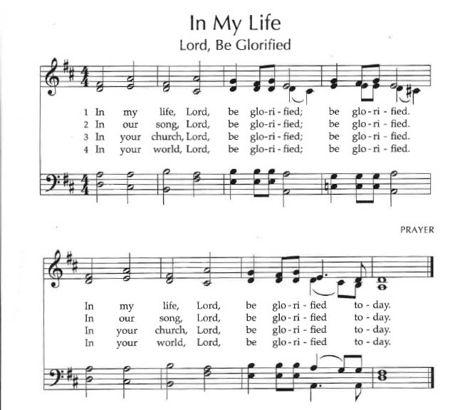
[*All stand as they are able.]

Serving Today at Westminster
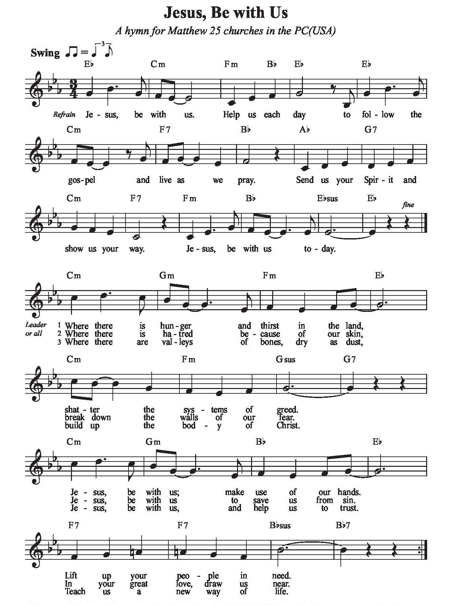
Pianist: Sally Kauffmann
Vocalists: Elizabeth Watkins and Sally Kauffmann
Liturgists: Elizabeth Watkins
Worship Hosts: Beth and David Hammond
Tech Team: Jacob Dennis
Adult Sunday School: Caroline Dennis
Children’s Sunday School Kathy Gillespie
Next Sunday, August 14
9:00 Sunday School Choir Room
10:00 Worship Sanctuary

ANNOUNCEMENTS

Sanctuary Flowers

The sanctuary flowers are given today by Steve and Claire Kuhl in celebration of their wedding anniversary.

Sunday School Cokesbury Campus
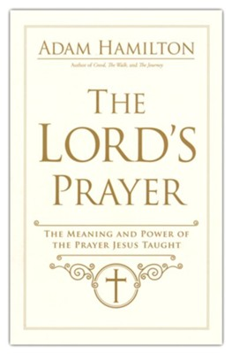
A new class starts today led by Rev. Caroline Dennis.

Most of us know the Lord's Prayer by heart, but do we really appreciate the power of its words? In this insightful 6-week study, author Adam Hamilton helps you find a deeper understanding of the petition you may have come to recite without thinking. Learn how it can serve as a pattern for your everyday devotional life.

Each session will include a brief video and plenty of discussion time! This study coordinates with Pastor Caroline’s lectionary-based sermon series on the Lord’s Prayer. And the children will also be learning about The Lord’s Prayer in their own study time.

You can order your copy of The Lord’s Prayer: The Power and Meaning of the Prayer that Jesus Taught, by Adam Hamilton, from your favorite online bookseller, including ChristianBook.com and Amazon.com.

Invitation to a Summer of Joyful Prayer

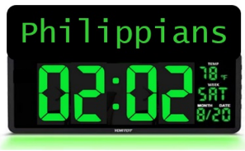
The Westminster Session invites you to a summer of joyful shared prayer by taking our Philippians 02:02 challenge. Starting on June 1, at 02:02 every day, Westminster family and friends will pause to pray wherever they are. To unify our prayers at that time, we will focus on Paul’s guidance to the Philippians in Chapter 2, Verse 2:

Sunday Sustenance

Rob Graves will once again invite everyone to join together for a meal following the service on Sunday, August 21, 2022. Anyone that would like to help Rob with set-up and/or break down, just call the office and volunteers will be communicated to Rob.

Family Night Supper to be Rescheduled

The Family Night Supper is being reschedule from August 24th until September. More announcements will be coming.

Greenwood County Food Bank 5K Walk Raises $13,000.

When You Pray, Move Your Feet” African Proverb often quoted by Rep. John Lewis. Jesus invited us to feed the hungry! So Westminster members and friends participated in this event and WPC was the water sponsor. The event was well attended and $13,000 was raised. When I learned that $13,000 was raised, my first thought was how amazing!! Then I learned that this would only feed 250 people for one month. How scary!!

WPC has participated in One Can Make a Difference program here for years…bringing in non-perishable that are then transported to the Food Bank.

Have you noticed when you have gone grocery shopping that the amount of money you spend has significantly increased? Particularly for meat and produce. I know I have. My first thought was I’ll just have to cut back on what I buy for the food bank. Then this little voice in my head said, “Are you crazy?” I stopped dead in my tracks. As I realized that I am being merely inconvenienced by these increased prices. YET there are more people than ever without enough food for their families. In that moment, I KNEW not only was I not going to cut back, but I was also going to increase what I buy.

Isaiah 58:7 Share your food with the hungry, and give shelter to the homeless. Give clothes to those who need them, and do not hide from relatives who need your help.

I ask each of you to join me and let’s help those in need. If you are not able to shop, the Food Bank is always happy to accept money. Every can and every dollar will help provide food for those in need.
Thank you, Kathy Felder

WESTMINSTER PRESBYTERIAN CHURCH
An Inclusive Community of Faith
United by Our Belief in and Commitment to Jesus Christ
Office Hours: M-Th 9:00 a.m. – Noon Office Phone: 864. 229.3595
www.wpcgnwd.org wpcgwd1@gmail.com

Reverend Caroline Vinson Dennis
Pastor (317.777.1487)
Sunday Study 9:00 a.m. Church Service: 10:00 a.m.
CCLI License #2724601 and #20189191

